Stock span problem


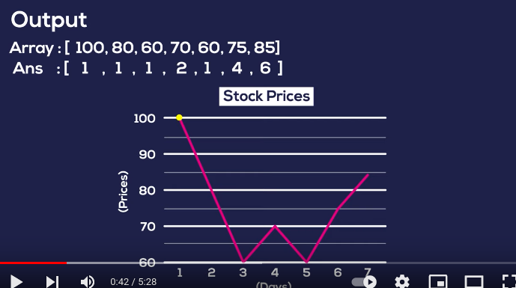

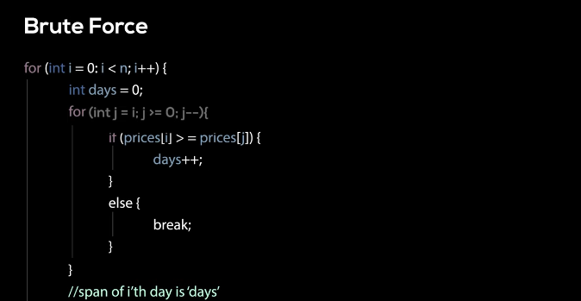
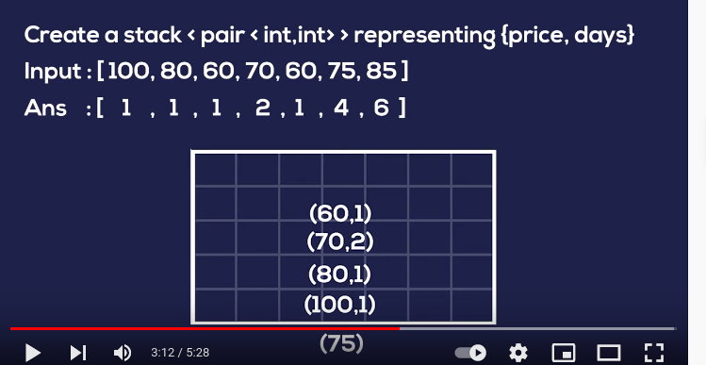
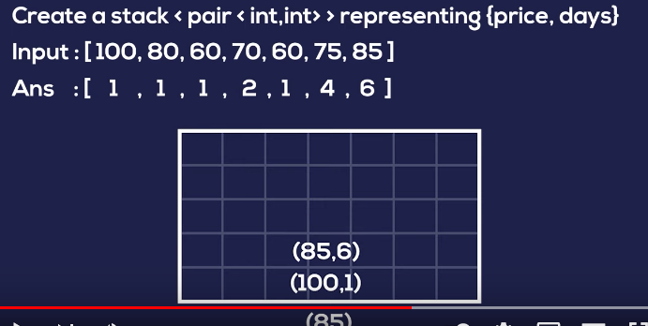

#include<bits/stdc++.h>
using namespace std;

vector<int> stock_span(vector<int> a){
vector<int>ans;
stack<pair<int,int>>st;
for(auto price: a){
int days=1;
while(!st.empty() and st.top().first<=price){
days +=st.top().second;
st.pop();

}
st.push({price,days});
ans.push_back(days);
}
return ans;
}

int main(){
vector<int>a={100,80,60,70,60,75,85};
vector<int> aa=stock_span(a);
for(auto aaa:aa){
cout<<aaa<<" ";
}
}

o/p
1 1 1 2 1 4 6

